Project Design Phase-II
Technology Stack (Architecture & Stack)

Date | 6 July 2026
Team ID | SWTID-2026-4431
Project Name | Strategic Product Placement Analysis

Technical Architecture:
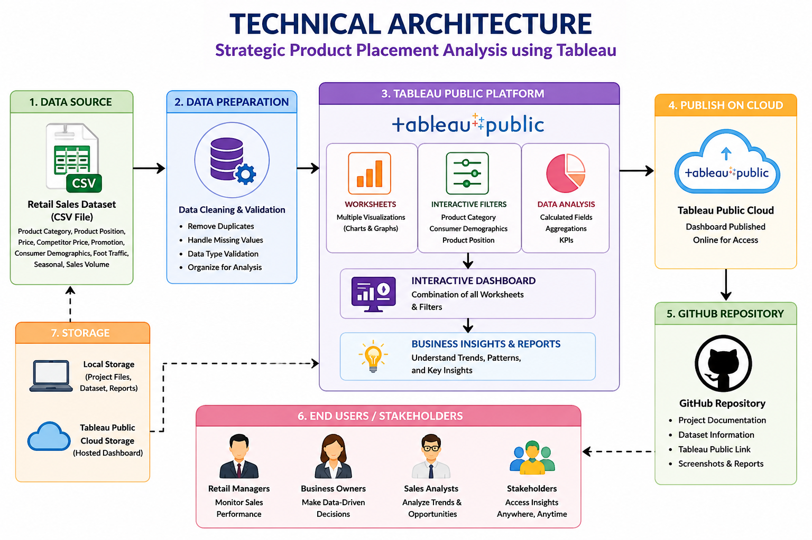

Table-1 : Components & Technologies:

S.No | Component | Description | Technology
 | User Interface | Interactive dashboard for retail sales analysis | Tableau Public
 | Application Logic-1 | Data import, cleaning and preparation | CSV Dataset + Tableau Public
 | Application Logic-2 | Interactive filters and dashboard interactions | Tableau Public
 | Application Logic-3 | Business analysis and data visualization using worksheets and dashboards | Tableau Public
 | Database | Retail sales dataset | CSV File
 | Cloud Database | Dashboard published online | Tableau Public Cloud
 | File Storage | Project files, dataset and documentation | Local Storage
 | External API-1 | Online dashboard publishing and sharing | Tableau Public
 | External API-2 | Project repository and documentation sharing | GitHub Repository
 | Machine Learning Model | Not Applicable
 | Infrastructure (Server / Cloud) | Local development and cloud dashboard hosting | Windows PC + Tableau Public Cloud

Table-2: Application Characteristics:

S.No | Characteristics | Description | Technology
 | Open-Source Frameworks | Dashboard development and version control | GitHub, Tableau public
 | Security Implementations | Secure repository and controlled dashboard access | GitHub, Tableau public
 | Scalable Architecture | Easily extendable with new dashboards and datasets | Tableau public
 | Availability | Accessible online anytime through web browser | Tableau public cloud
 | Performance | Fast interactive filters and smooth dashboard response | Tableau public

